A. Program Description:
The purpose of this program is to analyze the behavior of a simple RC circuit by computing the current and voltage across a capacitor over time. Given user input for time in microseconds, the program converts the input into seconds and calculates the corresponding values of current and voltage using exponential functions.

Inputs
- Time (t) in microseconds (entered by the user)
Outputs
- Current (i) in milliamps (mA)
- Voltage (v) in volts (V)
Program Structure
- The program uses sequential execution to define constants and read user input.
- It performs mathematical computations using predefined formulas.
- The final results are displayed using formatted output.

B. Program Flowchart:

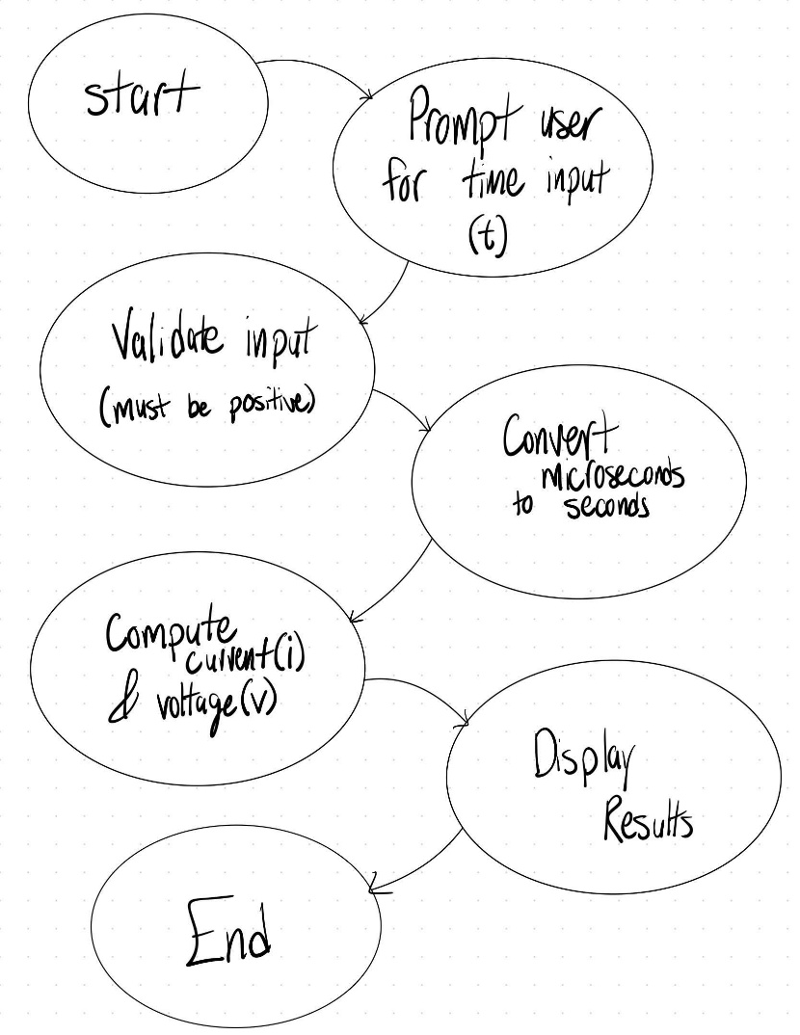

C. Source Code

#include <iostream>
#include <cmath>

using namespace std;

int main()
{
// Constants
const double V_DC = 10.0;
const double R = 10000.0;
const double C = 100.0e-12;

double t_micro; // Time in microseconds

// Prompt user for input
cout << "Enter time (t) in microseconds (us): ";
cin >> t_micro;

// Validate input (must be a number and positive)
if (cin.fail() || t_micro < 0) {
cout << "Invalid input. Please enter a positive numeric value." << endl;
return 1;
}

// Convert microseconds to seconds
double t = t_micro * 1e-6;

// Compute current (i) in mA
double i_t = (V_DC / R) * exp(-t / (R * C)) * 1000;

// Compute voltage (v) in V
double v_t = V_DC * (1 - exp(-t / (R * C)));

// Display results
cout << "Current, i(t): " << i_t << " mA" << endl;
cout << "Voltage, v(t): " << v_t << " V" << endl;

return 0;
}

D. Program Test Results:
t = 0
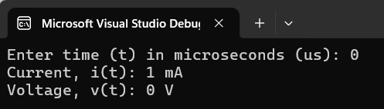
t = 0.1
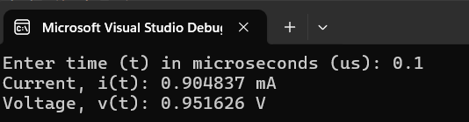
t = 0.2
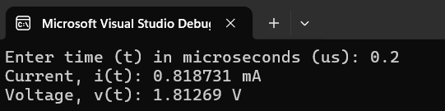
t = 0.5
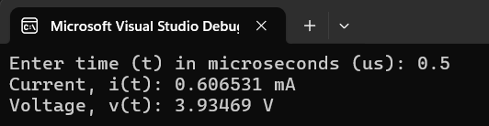

t = 1.0
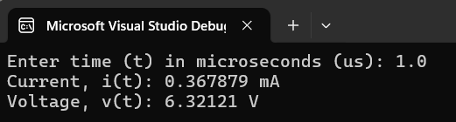
t = 2.0
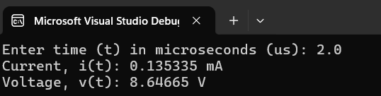
t = 5.0
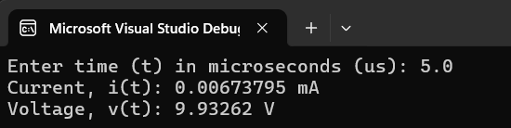

E. Tabulated Data.

Time ($t$) ($μS$) | Current, $i(t)$ (mA) | Voltage, $v(t)$ (V)
0 | 1 mA | 0 V
0.1 | 0.904837 mA | 0.951626 V
0.2 | 0.818731 mA | 1.81269 V
0.5 | 0.606531 mA | 3.93469 V
1.0 | 0.367879 mA | 6.32121 V
2.0 | 0.135335 mA | 8.64665 V
5.0 | 0.00673795 mA | 9.93262 V

